2021
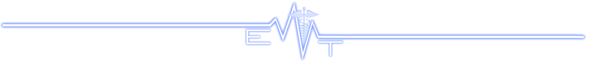
Phone 541.844.1328 Fax 541.636.3416

1144 Gateway Loop Suite 136 - Springfield, OR 97477
EMT. Associates@Comcast.Net
www.EMTAssoc.com
24-HOUR EMT REFRESHER

Oregon Course

Upon successful course completion you will receive:
- Course Completion Certification
* BLS Certification card $25
Individual days @ $185/day

Course Schedule:
Day 1 Pediatrics, OB
Day 2 Trauma
Day 3 Medical Emergencies (BLS Certification)
DATES | TIME | Course Location
Jan 17,23,24, 2021 | 8:00 – 6:30pm | EMT Associates Classroom 1144 Gateway Loop, St 136 Springfield, OR 97477
.

COURSE DATE(S) YOU WILL ATTEND: |  | License Number(STATE AND OR NATIONAL) and Expiration Date(s)
Last Name: | First Name: |  |  | Phone:
Address: |  |  | City: |  | State: | Zip
E-Mail (REQUIRED FOR PRE-COURSE MATERIALS):
 | Please fill in the bubbles FOR PURCHASES
 | 24-HOUR REFRESHER COURSE 2021  * FULL COURSE: select start date  January |  | $420
 | Day 1 ONLY: Pediatrics, OB Jan 17 |  | $185
 | Day 2 ONLY : Trauma Jan 23 |  | $185
 | Day 3 ONLY: Medical Emergencies  Jan 24 |  | $185
 | BLS Card |  | $25
 | BLS Textbook |  | $25
 | ACLS/PALS Handbook | $50
 | LATE REGISTRATION FEE | $50 |  | Registration less than 5 business days to course start and "drop-ins"  Payment Method: CREDIT/DEBIT CHECK CASH  Card Number: __ __ __ __ - __ __ __ __ - __ __ __ __ - __ __ __ __  Expiration Date __ __ / __ __ __ __ Security Code: __ __ __ __  Billing Zip Code __ __ __ __ __  Signature: ____________________________________________  In accordance with the Americans with Disabilities Act, please advise EMT Associates if you have any disability that requires special materials and/or services so that appropriate personnel can be advised. No planners or faculty have any relevant information to disclose
 | Shipping | $8
 | TOTAL PAID

Cancellation/Late Registration/No Show
Late registration is defined as registration received with less than 5 business days’ notice of paid enrollment, including “drop-ins”. Late Registration is a $50 Fee. Transfers made less than 5 business days prior to class will be charged a $50 processing fee.
No Call/No shows and late cancellations are responsible for full payment.

3 Ways to Register: 1. Online at WWW.EMTASSOC.COM 2. Fax to (541) 636-3416 3. Mail to 1144 Gateway Loop, Suite 136 - Springfield, OR 97477

